Bike Renting Project
by
Sonali Tajane

Content

1. Problem statement
2. Exploratory data analysis
3. Data preprocessing
3.1 Missing value analysis
3.2 Data visualization
3.3 Outlier analysis
3.4 Feature selection
4. Data modeling
5. Conclusion

Problem statement

The objective is to Predication of bike rental count on daily based on the environmental and seasonal settings.

Exploratory data analysis

Dimension of dataset is 731*16

On analysing the dataset, we get to know that the feature “instant” is just a serial number and does not contribute any information needed for predicting bike count. From feature “dteday”, we see that most of the useful information like year, month, weekday is already extracted and features like “casual” and “registered” is nothing but the total count is sum of these two variables.

Hence, we are dropping these variables. We are categorizing variables of dataset into numerical and categorical variable.

Categorical variables : "season","yr","mnth","holiday","weekday","workingday","weathersit"

Numerical variables : "temp","atemp","hum","windspeed", "cnt"

Data preprocessing

3.1 Missing value analysis

Before going further, we should do missing value analysis as data can be missing due to various reasons, and if the data is misiing we have to impute missing values with mean,median,mode.

In this dataset,there are no missing values

season 0
yr 0
mnth 0
holiday 0
weekday 0
workingday 0
weathersit 0
temp 0
atemp 0
hum 0
windspeed 0
casual 0
registered 0
cnt 0

Data visualization

We have to visualize the dataset to get more information about features

bike count is minimum in the spring season whereas the maximus in fall season

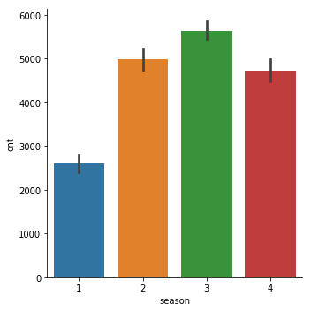

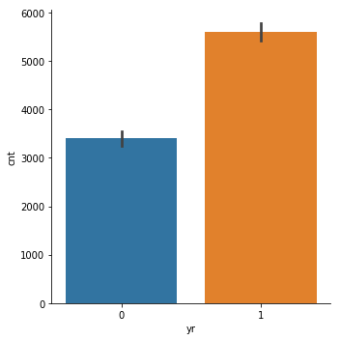
Year 2012 has more bike rental than year 2011

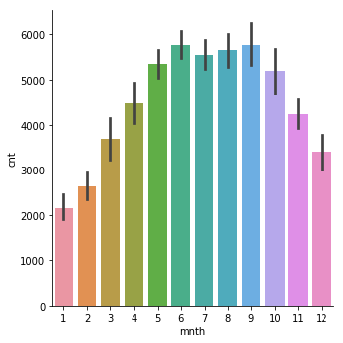

Few months i.e june, August, September can be seen as peak season

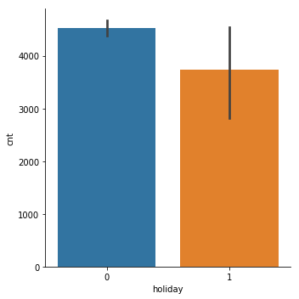

people use bike more on working days than on holidays.

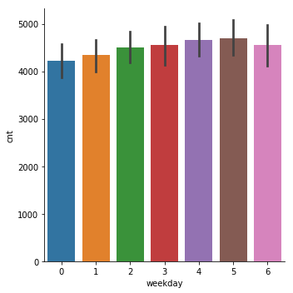
Slight variations in weekday bike rental count

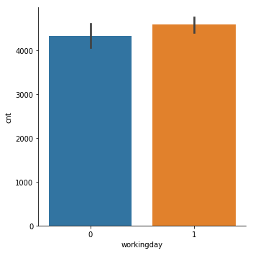

bike rental count on working days is slightly higher than the count on nonworking days

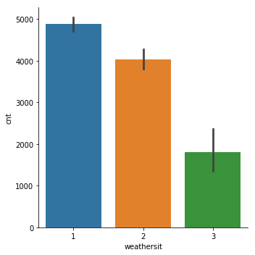
Bike rental count is higher on clear, partly cloudy day whereas during heavy rains no one would rent a bike

Outlier analysis

outliers are data points that don’t belong to certain points. In the dataset windspeed and hum shows outlier.

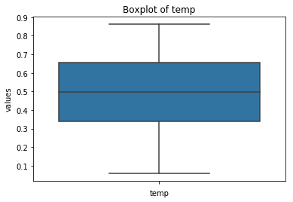

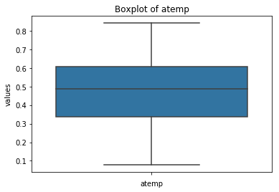

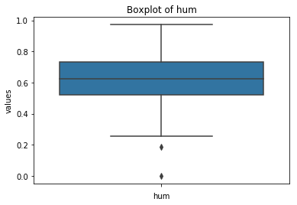

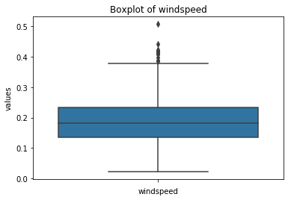

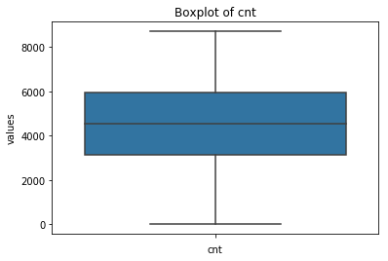

Feature scaling

Data is unimormly distributed which is as follows

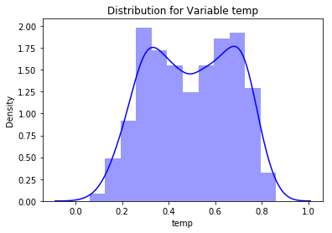

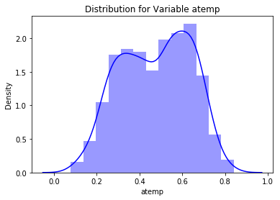

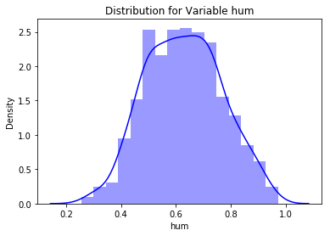

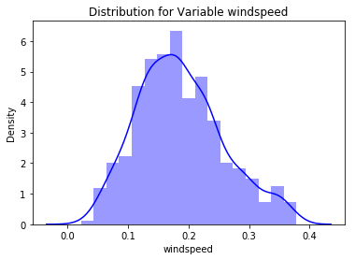

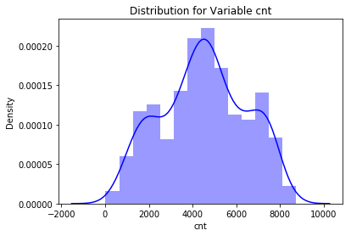

Feature selection
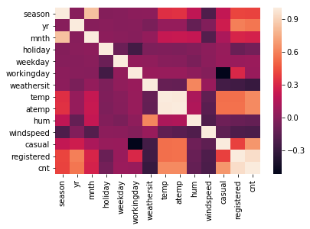

In the dataset, “temp” and “atemp” are highly correlated, so one of them can be dropped while “holiday”,”weekday”,”workingday” don’t contribute much to count.

Dropped features are as follows
instant, dteday, atemp, holiday, weekday, workingday, casual,registered

Data Modeling

It is a case of supervised learning. Linear regression, decision tree, random forest algorithm have been applied and results is as follows-

Linear regression
MAPE - 0.269488885123541
MAE is- 715.5115825222186
Mean Square : 942234.3682178443
Root Mean Square : 970.6875749786046

Decision tree
MAPE - 0.28342394557134615
MAE - 770.5238095238095
Mean Square - 1156787.380952381
Root Mean Square -1075.5405064210186

Random forest
MAPE - 0.25176914936345385)
MAE - 591.4496802721088)
Mean Square- 698882.3076653945)
Root Mean Square- 835.991810764552)

Conclusion

Linear regression, decision tree and random forest model have been applied and of all them random forest is best suitable.

